BeyondTrust Remote Access Software

Objective
Install and use BeyondTrust (Bomgar) to perform remote access to a user's machine.

Step by Step
- To use Bomgar you must have a license, which can be requested through a ticket to Desktop Engineering via ServiceNow as follows:
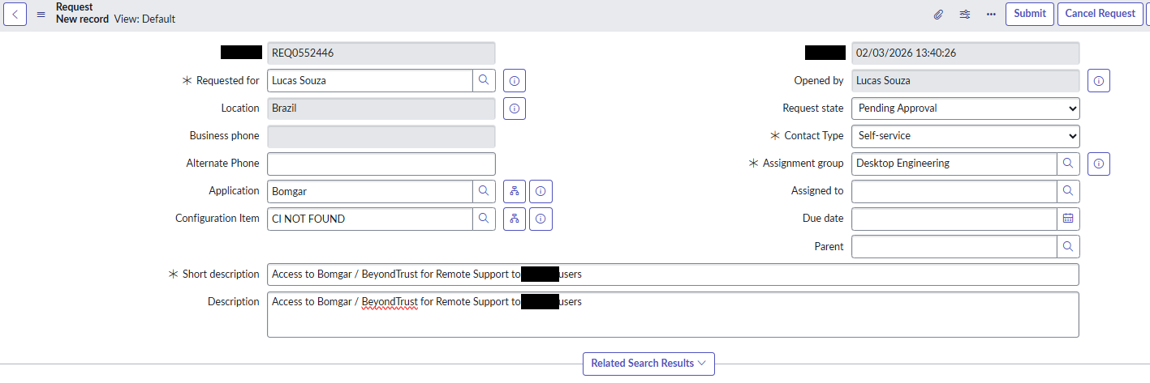

Software Installation
- Go to: https://itsupport.contoso.com/login/login and select Authentication as 'SAML Credentials'
- Click Log in.
- Click Download Representative Console.
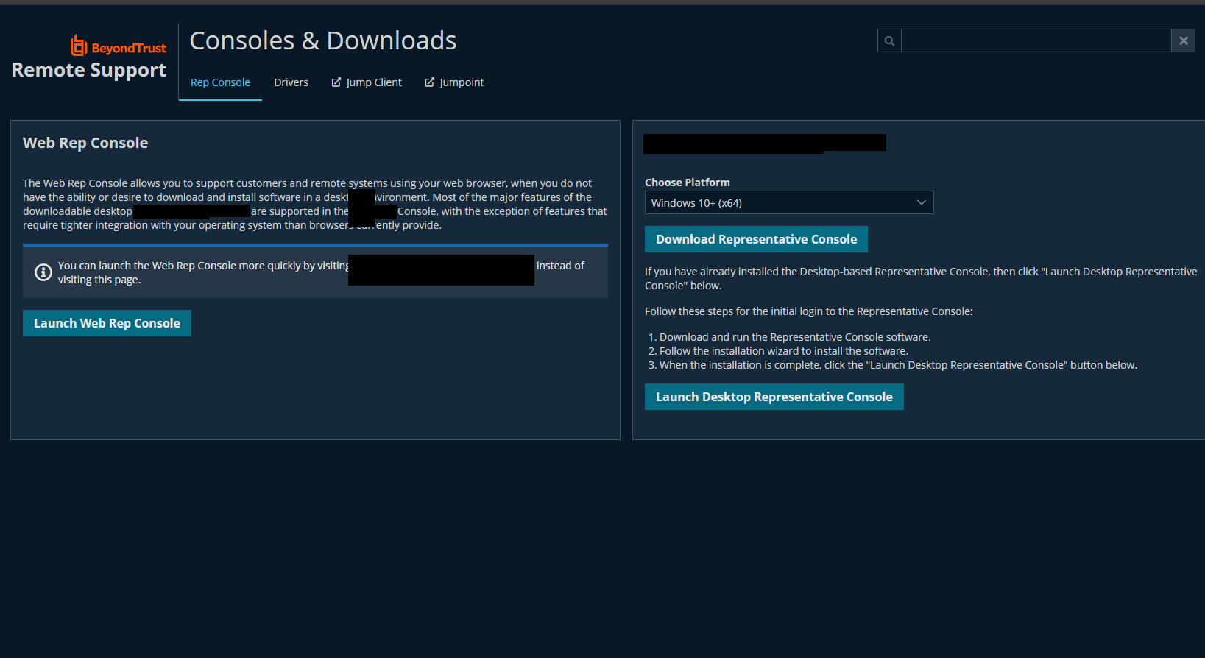
- Run the installer.
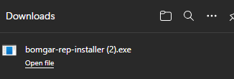
- Proceed through the installation normally.
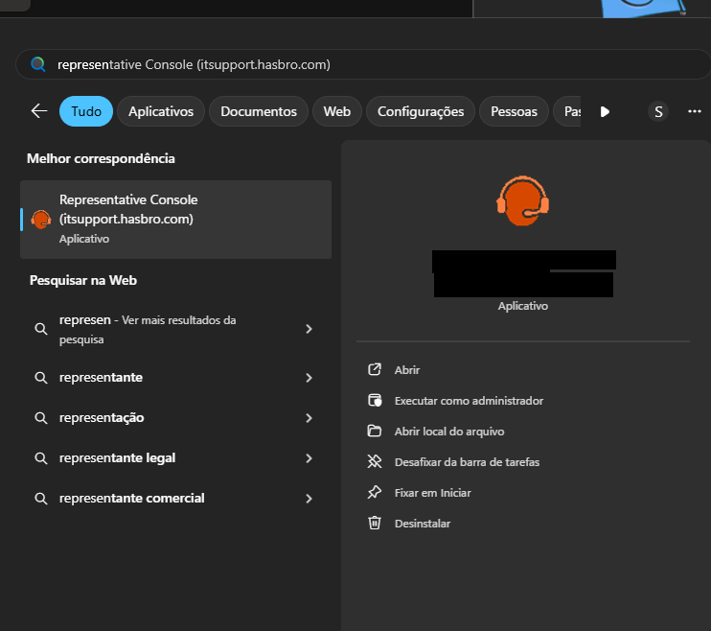
- Go to the Start menu and locate the Bomgar program. Click Representative Console [itsupport.contoso.com].
- When launched, the program will prompt for your credentials.
- Select SAML Credentials and click to log in.
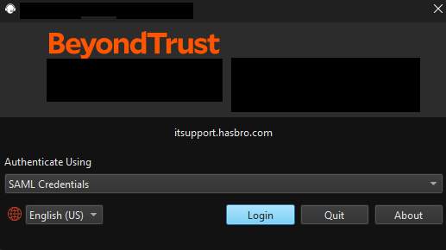
- This is the Bomgar home screen; click Start.
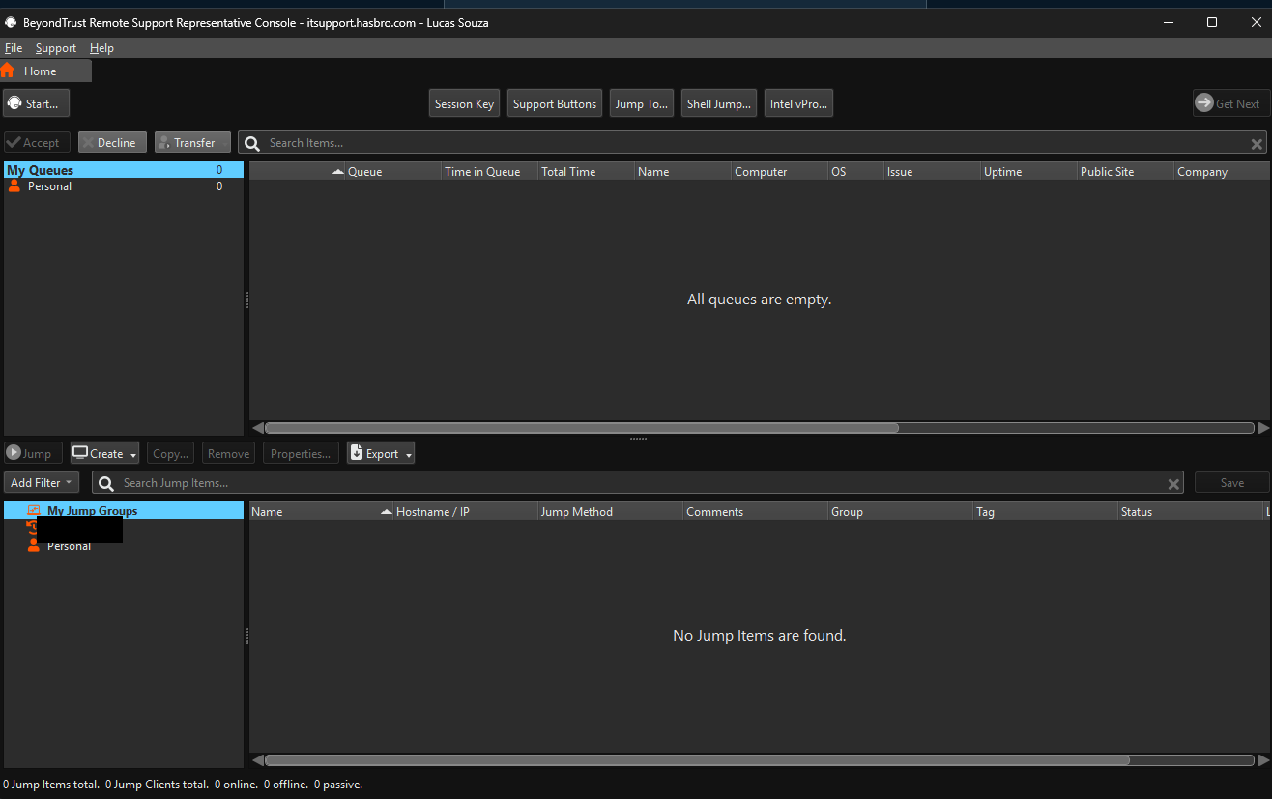
- There are three options to start a remote session via Bomgar; the most commonly used is the first option: Representative List.
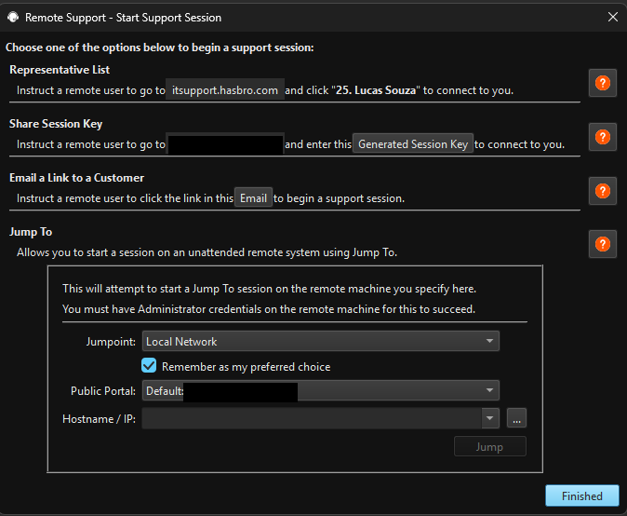
- Instruct the user to access the link http://itsupport.contoso.com.
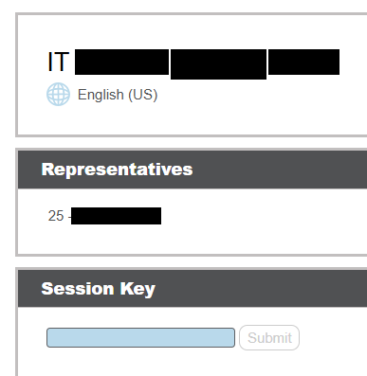
- Instruct the user to click on the name of the analyst who will access the machine remotely.
- The screen below will be displayed and the download of the executable will start automatically; after completion, ask the user to open the downloaded executable.
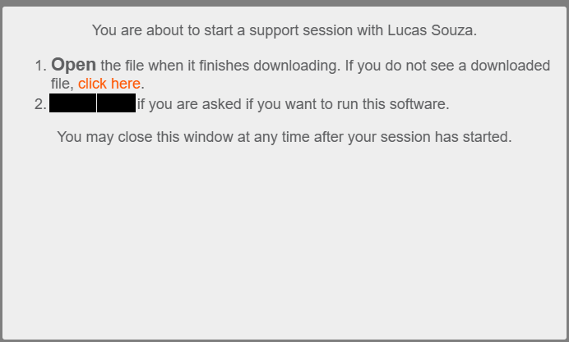
- Click 'Open file' after completion.
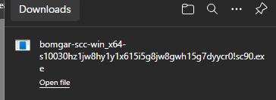
- After the user runs it, the analyst who has the Representative Console software open on their computer will see a new connection appear; double-click on the connection to start the remote session.
- Click 'SCREEN SHARING'
- Wait while the user grants access.
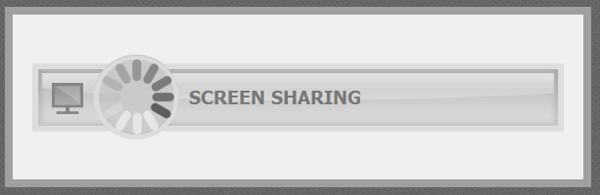
- The user's screen will then be displayed.

Version History
Author | Version | Date | Description
Lucas Souza | 1.1 | 02/03/2026 | Updated tool naming and access method.
Lucas Souza | — | Jun/2026 | Document standardization

